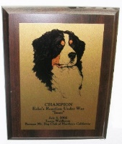
DID YOUR DOG EARN A TITLE OR CERTIFICATE IN 2022? CONGRATULATIONS! YOU MAY BE ELIGIBLE FOR RECOGNITION AT THE BMDCNC ANNUAL AWARDS MEETING
To be eligible for a plaque or certificate you must be a BMDCNC member and the title must be earned by a dog living in the member’s home at the time the title is earned. All awards must be picked up at the awards meeting.
BMDCNC SUPPLIES ONLY ONE PERPETUAL PLAQUE PER DOG. ADDITIONAL PLAQUES MAY BE PURCHASED AT OWNER’S EXPENSE. PLATES WILL BE SUPPLIED FOR EVERY TITLE EARNED. Please contact me for details.
Title Plaques are awarded for titles in: AKC Conformation, Obedience, Rally, Tracking, Agility, Herding, Therapy Dog (THDD title), Scent Work, BMDCA Draft and titles from other organizations such as AHBA, BHA, NACSW, and NADD. Please contact me if the title you earned is not on this list.
Certificates are awarded for: Canine Good Citizen (CGC & CGCA), Herding instinct, Temperament test, Odor recognition tests, Trick Dog titles, Therapy or Service dog certification, BMDCA awards such as Top Producer or Achiever, Working Dog awards and Versatility awards, and other similar certifications.
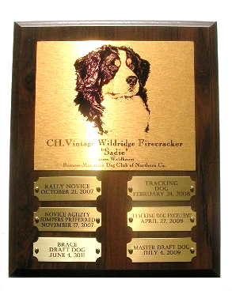
Please note that you have a choice of styles for title plaques – please see the form below. Awards will be presented at the Annual Membership Meeting and Awards Meeting April 22, 2023.
INFORMATION MUST BE SUBMITTED ON THIS FORM (email or mail this completed form along with your plates to be engraved). FORMS AND PLATES MUST BE RECEIVED BY LAURA NO LATER THAN 5pm March 20, 2023. NO EXCEPTIONS!!

Dog’s Registered Name Click here to enter text.

Dog’s Call Name Click here to enter text.

BMDCNC Member’s Name Click here to enter text.

Contact info: E-Mail Click here to enter text. Phone Click here to enter text.

Certificate(s) earned in 2022 with date(s) earned Click here to enter text.

Title(s) earned in 2022 with date(s) earned Click here to enter text.

PLAQUES ARE AVAILABLE AS 7” X 9” SINGLE TITLE WOOD PLAQUES OR PERPETUAL TITLE WOOD PLAQUES WITH EITHER 6 METAL TITLE PLATES (8” X 10”) OR 12 METALTITLE PLATES (10” X 13”). PLEASE SELECT EITHER METAL STOCK ILLUSTRATION - BERNER HEAD- OR YOUR DOGS PHOTO ON METAL. PLEASE SELECT FROM CHOICES BELOW:

☐ I already have a perpetual plaque and I want to add a plate to it for a:
☐ new title, ☐ new dog
Please mail a blank plate from your existing plaque to Laura Waldbaum with this form
-------------------------------------------------------------------------------------------------------------------------------
☐ I would like a single title plaque with stock illustration head study
☐ I would like a single title plaque with my own dog’s photo. PHOTO MUST ACCOMPANY THIS FORM Electronic photos must be JPEG format minimum 300dpi
-------------------------------------------------------------------------------------------------------------------------------
☐ I would like a 6 PLATE PERPETUAL PLAQUE with:
☐ Stock head study illustration for a SINGLE TITLE (plates will be for different dogs earning the same title)
☐ Stock head study illustration for a SINGLE DOG (plates will be for new titles)
☐ Your berner’s photo with plates for different titles earned by this dog -PHOTO MUST ACCOMPANY THIS FORM Electronic photos must be JPEG format minimum 300dpi
-----------------------------------------------------------------------------------------------------------------------------
☐ I would like a 12 PLATE PERPETUAL PLAQUE with
☐ Stock head study illustration for a SINGLE TITLE (plates will be for different dogs earning the same title)
☐ Stock head study illustration for a SINGLE DOG (plates will be for new titles)
☐ Your berner’s photo with plates for different titles earned by this dog -PHOTO MUST ACCOMPANY THIS FORM Electronic photos must be JPEG format minimum 300dpi
-------------------------------------------------------------------------------------------------------------------------------

PLEASE RETURN ONE FORM FOR EACH TITLE PLAQUE OR CERTIFICATE BY March 20, 2023 TO LAURA WALDBAUM
By Mail: Laura Waldbaum, By E-mail: laura@waldbaumswildridge.com
BMDCNC Annual Awards
7945 St Helena Rd. Santa Rosa CA 95404

Questions (707) 539-5773 (Please no calls after 7pm)

I will contact you to confirm receipt of your form. IF YOU DO NOT HEAR BACK FROM ME WITHIN ONE WEEK OF YOUR SUBMISSION. I DO NOT HAVE YOUR FORM.

